Bulletin or Newsletter Ad #1



Join us for the 12th annual
Catholic Schools Walk
at “insert event location”!
“Insert event date and time”

The Soles for Catholic Education Walk is now simply, Catholic Schools Walk. Join us as we walk to celebrate Catholic schools, build community, and raise funds that stay at our school. Help us reach our school’s fundraising goal of “insert goal $ amount” so we can purchase “insert goal”! Register today, and help us reach our goal by asking family, friends and neighbors to make a donation.

Donations made to our walkers stay right here at “School Name”!

To donate: text SCHOOLSWALK”insert your text-to-give # here” to 71777, or visit catholicschoolswalk.org.

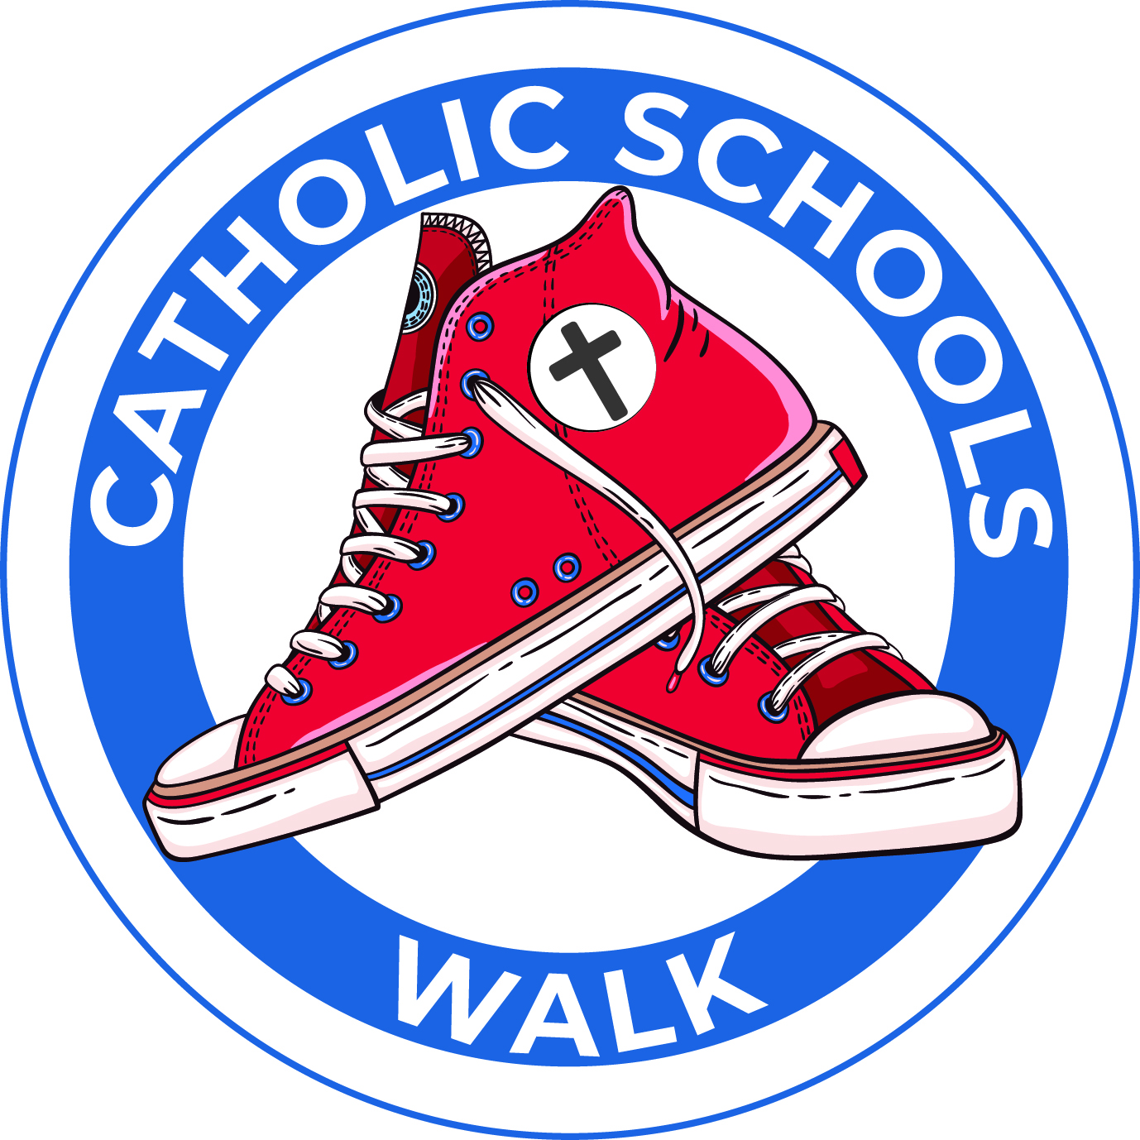



Join us for the 12th annual
Catholic Schools Walk
at “insert event location”!
“Insert event date and time”

The Soles for Catholic Education Walk is now simply, Catholic Schools Walk. Join us as we walk to celebrate Catholic schools, build community, and raise funds that stay at our school. Help us reach our school’s fundraising goal of “insert goal $ amount” so we can purchase “insert goal”! Register today, and help us reach our goal by asking family, friends and neighbors to make a donation.

Donations made to our walkers stay right here at “School Name”!

To donate: text SCHOOLSWALK”insert your text-to-give # here” to 71777, or visit catholicschoolswalk.org.

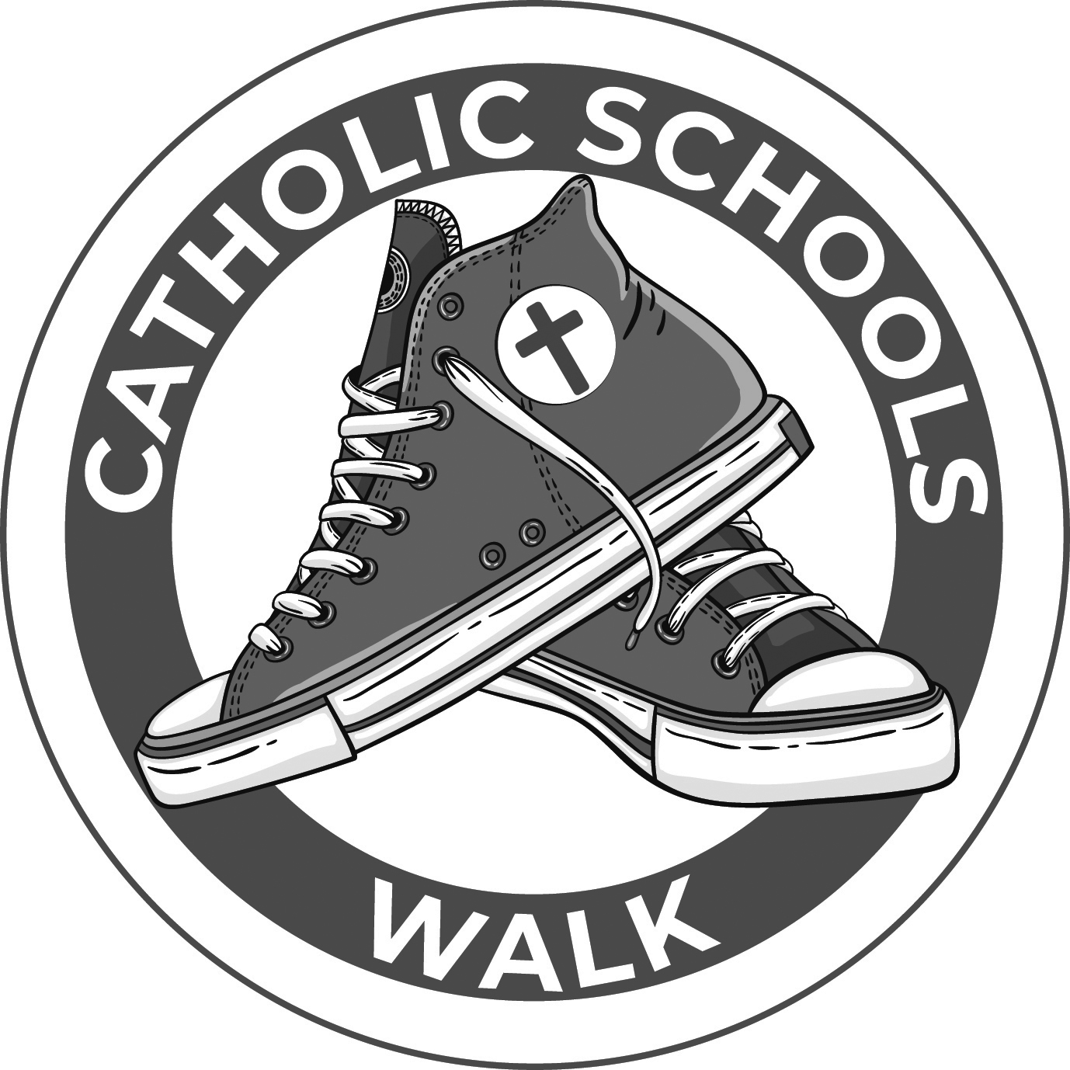

Please note you need to add your school name, School Walk Captain name and contact information to the ad copy.

Bulletin or Newsletter Announcement #1
Join us for the 12th annual Catholic Schools Walk on “insert date” at “insert event location”.

The Soles for Catholic Education Walk is now simply, Catholic Schools Walk. Join us as we walk to celebrate Catholic schools, build community, and raise funds that stay at our school.

Help “insert school name” reach our school’s fundraising goal of “insert goal $ amount” so we can purchase “insert goal”! Register today, and help us reach our goal by asking family, friends and neighbors to make a donation.

Donations made to our walkers stay right here at “School Name”!

To donate, text SCHOOLSWALK”insert your text-to-give # here” to 71777, or visit catholicschoolswalk.org.

