Bulletin or Newsletter Ad #3



Support “School Name”

Catholic school students, parents, teachers, alumni and friends will gather together on “insert event date” for the annual Catholic Schools Walk.

Donations made to our team stay right here at [School Name] to help us reach our school’s fundraising goal of “insert dollar amount” for “insert what raising money for”.

The impact of your donation will do even more to help our school. Generous Catholic Schools Walk sponsors have stepped up to match a proportion of donations that “insert school name here” receives.

Donate today by texting SCHOOLSWALK“insert your text-to-give # here” to 71777, or visit catholicschoolswalk.org. To donate with cash or check, contact “School Captain Name” at “Phone Number” or “Email”.

What: Annual Catholic Schools Walk
Where: “insert where you are walking here”
When: “insert event date and time”

Thank you for supporting Catholic education.

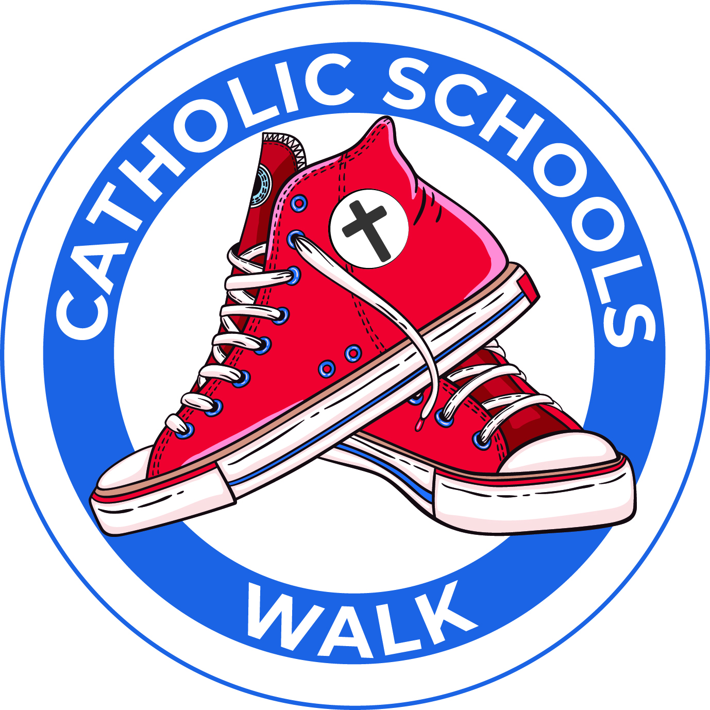



Support “School Name”

Catholic school students, parents, teachers, alumni and friends will gather together on “insert event date” for the annual Catholic Schools Walk.

Donations made to our team stay right here at [School Name] to help us reach our school’s fundraising goal of “insert dollar amount” for “insert what raising money for”.

The impact of your donation will do even more to help our school. Generous Catholic Schools Walk sponsors have stepped up to match a proportion of donations that “insert school name here” receives.

Donate today by texting SCHOOLSWALK“insert your text-to-give # here” to 71777, or visit catholicschoolswalk.org. To donate with cash or check, contact “School Captain Name” at “Phone Number” or “Email”.

What: Annual Catholic Schools Walk
Where: “insert where you are walking here”
When: “insert event date and time”

Thank you for supporting Catholic education.

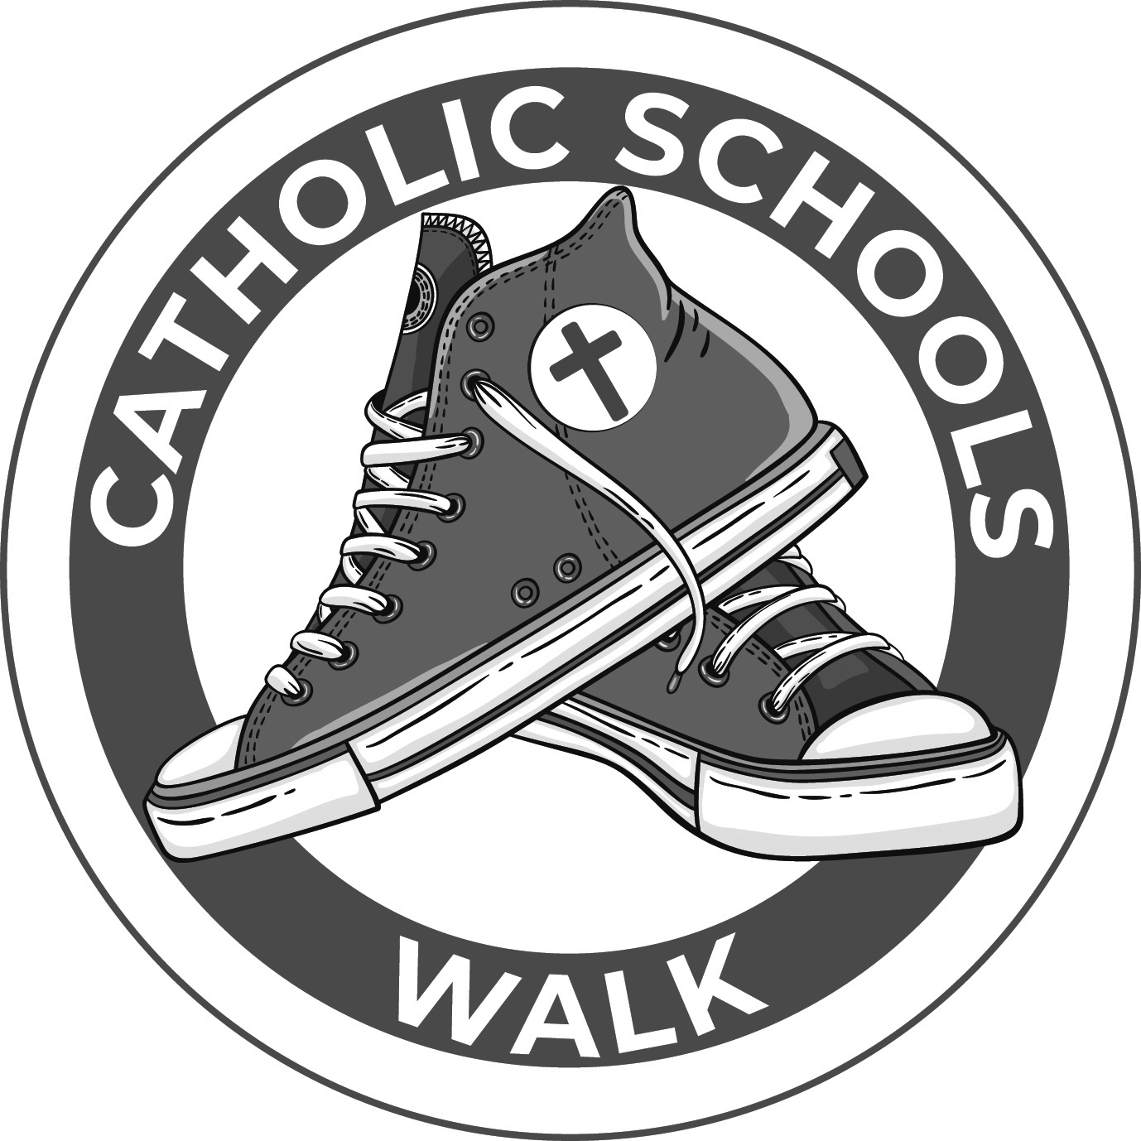

Bulletin or Newsletter Announcement #3

Your donation will be proportionally matched!

Support “School Name”

Catholic school students, parents, teachers, alumni and friends will gather together on “insert event date” for the annual Catholic Schools Walk.

Donations made to our team stay right here at [School Name] to help us reach our school’s fundraising goal of “insert dollar amount” for “insert what raising money for”.

The impact of your donation will do even more to help our school. Generous Catholic Schools Walk sponsors have stepped up to match a proportion of donations that “insert school name here” receives.

Donate today by texting SCHOOLSWALK“insert your text-to-give # here” to 71777, or visit catholicschoolswalk.org. To donate with cash or check, contact “School Captain Name” at “Phone Number” or “Email”.

What: Annual Catholic Schools Walk
Where: “insert where you are walking here”
When: “insert event date and time”

Thank you for supporting Catholic education.

