Bulletin or Newsletter Ad #4



Thank you for joining Catholic school students, parents, teachers, alumni and friends who walked in support of Catholic education in 12th annual Catholic Schools Walk.

There is still time to make a Catholic Schools Walk donation to help {insert school name here} reach our fundraising goal. The impact of your donation will do even more to help our school thanks to generous Catholic Schools Walk sponsors that are matching a proportion of donations that {insert school name here} receives.

Donate today by texting SCHOOLSWALK“insert your text-to-give # here” to 71777, or visit catholicschoolswalk.org.

Contact “School Captain Name” at “Phone Number” or “Email” to donate with cash or check.

Thank you for supporting Catholic education.

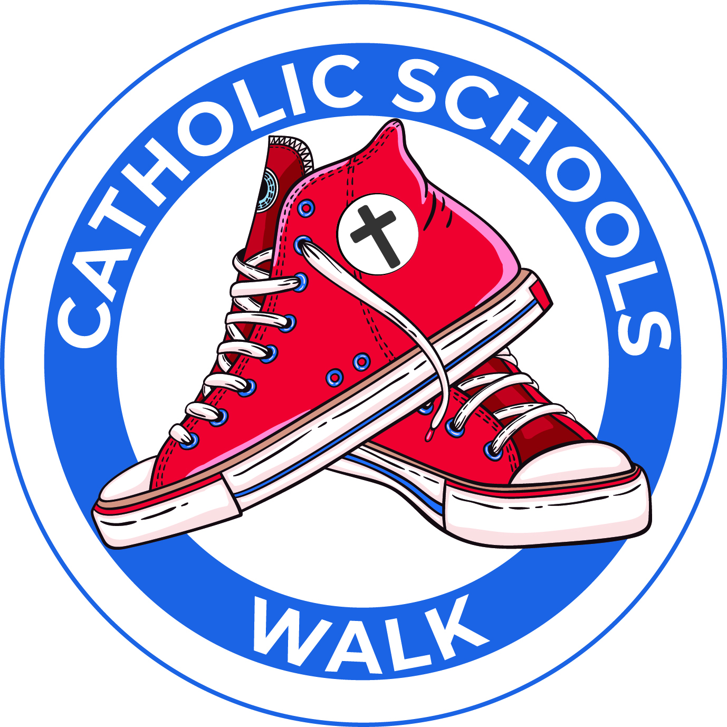



Thank you for joining Catholic school students, parents, teachers, alumni and friends who walked in support of Catholic education in 12th annual Catholic Schools Walk.

There is still time to make a Catholic Schools Walk donation to help {insert school name here} reach our fundraising goal. The impact of your donation will do even more to help our school thanks to generous Catholic Schools Walk sponsors that are matching a proportion of donations that {insert school name here} receives.

Donate today by texting SCHOOLSWALK“insert your text-to-give # here” to 71777, or visit catholicschoolswalk.org.

Contact “School Captain Name” at “Phone Number” or “Email” to donate with cash or check.

Thank you for supporting Catholic education.

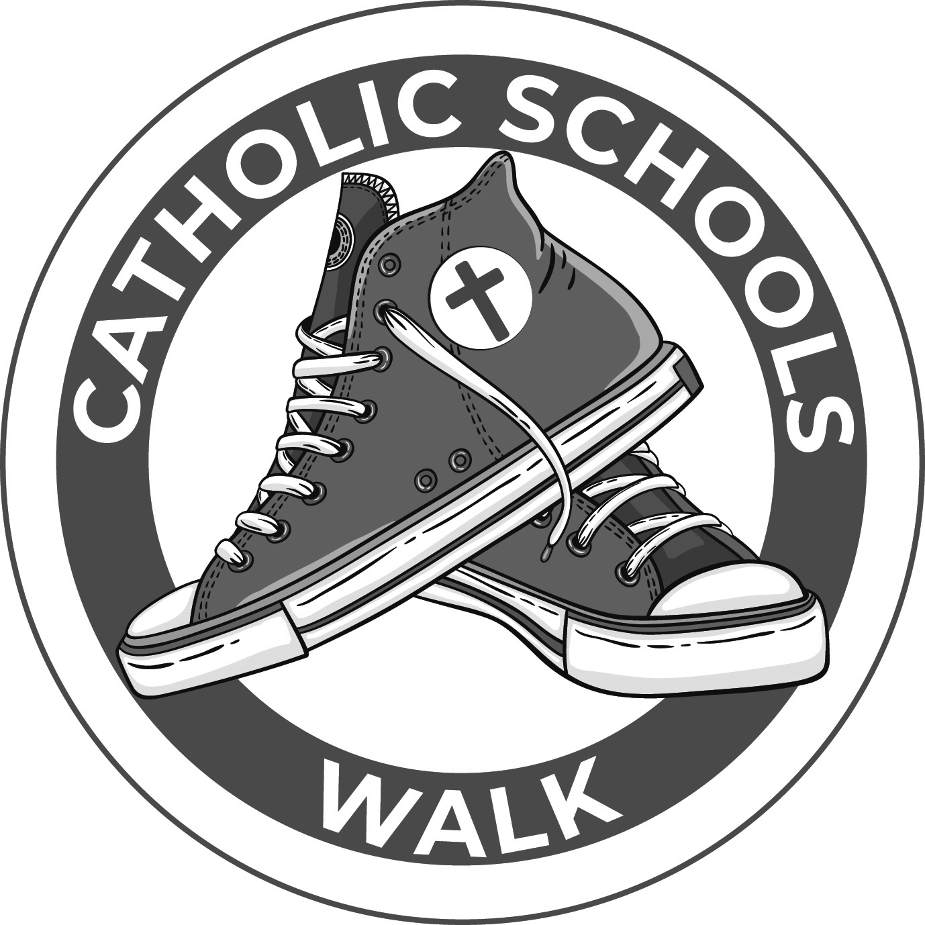

Bulletin or Newsletter Announcement #4

Thank you for walking with our school!

Thank you for joining Catholic school students, parents, teachers, alumni and friends who walked in support of Catholic education in 12th annual Catholic Schools Walk.

There is still time to make a Catholic Schools Walk donation to help {insert school name here} reach our fundraising goal. The impact of your donation will do even more to help our school thanks to generous Catholic Schools Walk sponsors that are matching a proportion of donations that {insert school name here} receives.

Donate today by texting SCHOOLSWALK“insert your text-to-give # here” to 71777, or visit catholicschoolswalk.org. Contact “School Captain Name” at “Phone Number” or “Email” to donate with cash or check.

Thank you for supporting Catholic education.

