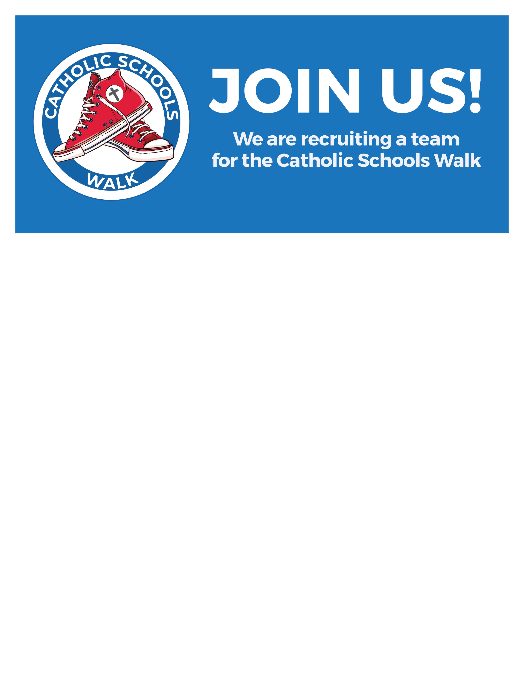

Join us for the 12th annual Catholic Schools Walk held at “insert event location” on “insert event date”.
Soles for Catholic Education Walk is now simply, Catholic Schools Walk. Our Catholic school’s walk will continue the tradition of celebrating Catholic education, building community, and raising much-needed funds that will benefit classrooms and students.
“Insert school name here” is forming a Catholic Schools Walk team to raise “insert goal $ amount” for “insert goal”. Register today, and help us reach our goal by asking family, friends and neighbors to make a donation.
Is there a registration fee, and how do I register? There is no fee to register for the 12th annual Catholic Schools Walk. Please go to catholicschoolswalk.org, find your school, click “view,” then click “Register to Walk” and complete the form.
Where will “insert school name here” walk? “insert information about where your school will walk here”
How can I raise money to help “insert school name here” meet its fundraising goal? It’s easy; all you have to do is become a Catholic Schools Walk fundraiser. You can create your own fundraising page at catholicschoolswalk.org, and ask your family, friends and neighbors to help you raise money. Use and share your school’s text-to-give number. People can text SCHOOLSWALK”insert your school’s text to give # here” to 71777, give online via catholicschoolswalk.org or bring cash or check donations directly to the school office.
Remember, 100% of donations raised will directly benefit students at “insert school name here”!
If I’m unable to walk at the event, can I still donate? Yes! Text SCHOOLSWALK”insert your school’s text to give # here” to 71777, give online via catholicschoolswalk.org or bring a cash or check donation directly to the school office.
Questions? Contact your Team Walk Captain, “insert name”, at “insert email and phone number”.

Thank you for supporting “insert school name here” and Catholic education!

